Introduction
Since 2015 the percentage of secondary students who answer “Yes” to the question “During this school year have other students bullied or harassed you?” on the Youth Truth Survey has increased. For grades 7-9, students who report being bullied has risen from 27% in 2015 to 30% in 2016 and 33% in 2017. For high school students, the increase has been from 14% to 17% to 20% in 3 years.

Summary
While students’ reports of bullying have increased in general, when broken down by grade and form (electronic, physical, social, verbal), trends vary. We can see, for instance, that 7th and 10th graders—who are the newest students on their respective campuses—have a larger growth increment in verbal and social bullying from than the other grades, which, while still high, have stayed more or less similar since 2015.
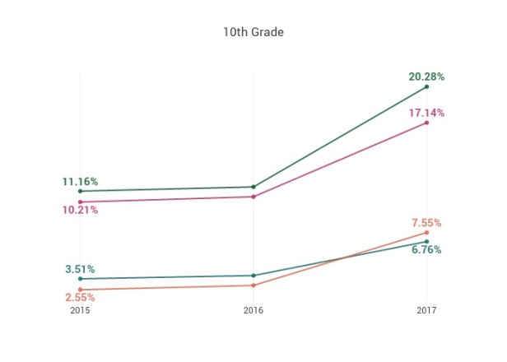
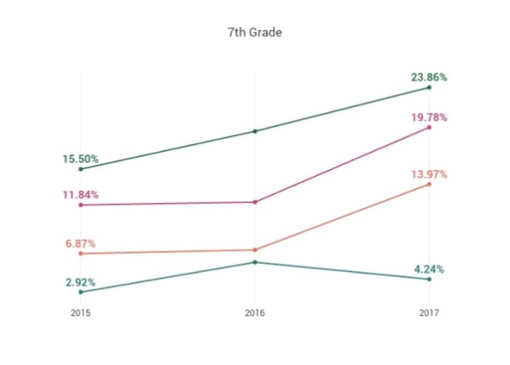
Of Students Who Have Experienced Bullying This Year, Percentages of each Particular Format, by Grade

Grades 7-9 594 students
Grades 10-12 409 students

Surveys administered
October 2015 October 2016 October 2017
10th Grade
7th Grade
2015 2016 2017

2015 2016 2017
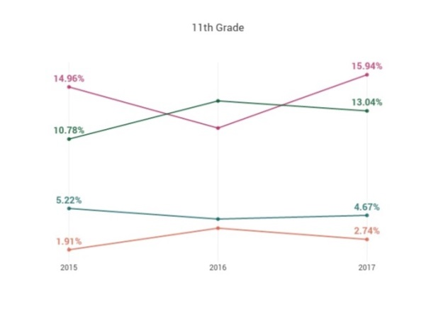
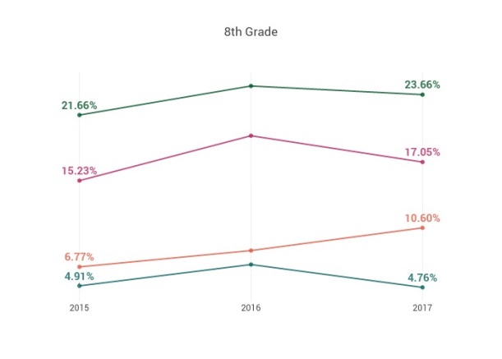
8th Grade
11th Grade
2015 2016 2017

2015 2016 2017
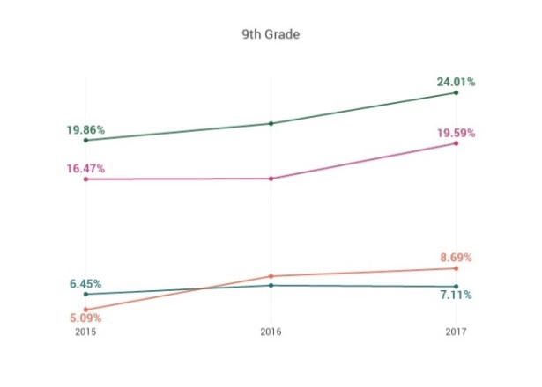
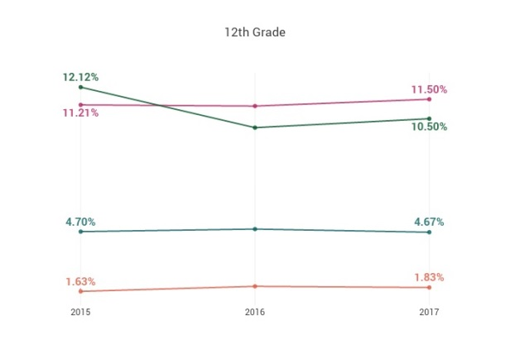
•Verbally• •Socially• •Physically• •Through cyberbullying•
9th Grade
12th Grade

2015 2016 2017
2015 2016 2017

Implications
Among the implications of these data is the question of how to understand the increases in 7th and 10th grade rates of experiencing bullying, and whether there are ways to directly and effectively address this. It is also worthwhile to note that students’ experiences of cyberbullying have for the most part stayed the same or decreased since 2015. One potential area of inquiry is the question of whether students’ understanding of cyberbullying excludes social media. In any case, across all secondary grades, verbal and social bullying remain the most prevalent forms of harassment and merit continued attention in positive climate building efforts in DJUSD.

